**­­­­­­­**

|  |  |
| --- | --- |
| JSW USER GUIDE FOR PHASE 1 | |
| **Submitted To:** | **Submitted By:**  Bodhtree Consulting Ltd., Block A, Wing 2,  Level 6,Cyber Gateway, HITEC City, Madhapur, Hyderabad – 500081.  Phone: +91-40-6622.2333  Fax: +91-40-6622.2444 |



## Application Flowchart

### Login Application

When a user has to login the application next time, he should follow the steps below.

1. Click on the URL below or type the same in the browser to access the application.

Sandbox: <https://test.salesforce.com/>

Production: <https://login.salesforce.com/>

1. Enter the Username and Password.
2. Click on Log in to Salesforce button as shown below.



### Activating Your Computer

You might be prompted to enter a token (also called a verification code) when you log into Salesforce to activate your computer. Computer activation allows Salesforce to verify your identity and prevent unauthorized access to the service whenever your password is changed or reset, or when you log in from a computer you have not previously used to access Salesforce.

1. When prompted, select how you would like to get the token:
2. Enter the token or verification code in Salesforce.
3. Click Validate and Log In.

**1. Sales Officer Login Page**

**User need to login with Sales Officer credentials**

Enter User name, Password and click on Login to salesforce button



Navigated to “Home” page as default landing page.

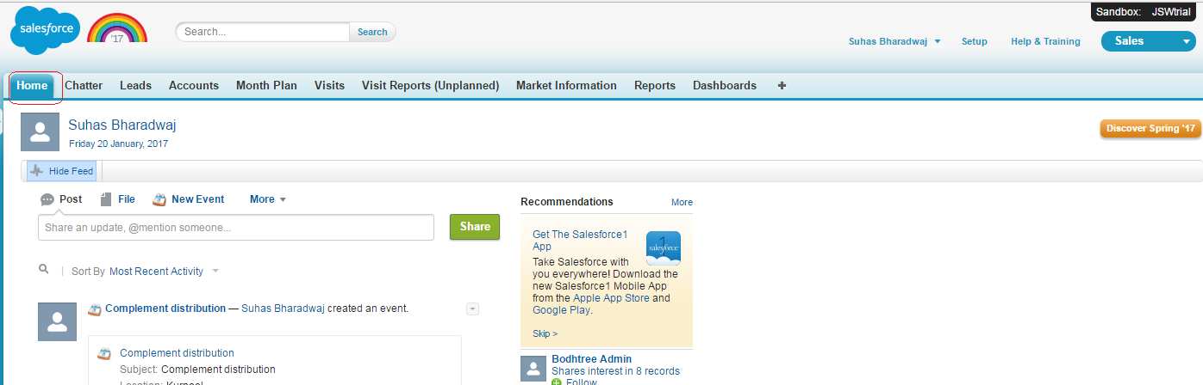

**2. Create Month Plan (PJP) for Sales Officer**

**2.1 Month plan landing page**

1) Click on “PJP” Tab to navigate to Month plan landing page

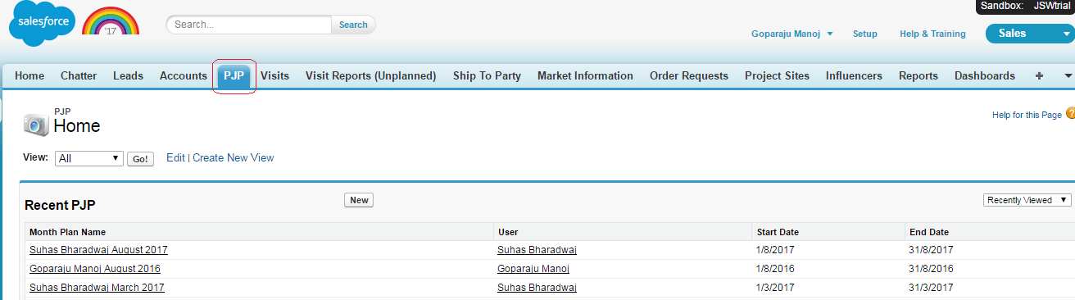

2) Display all existing Month plan records .

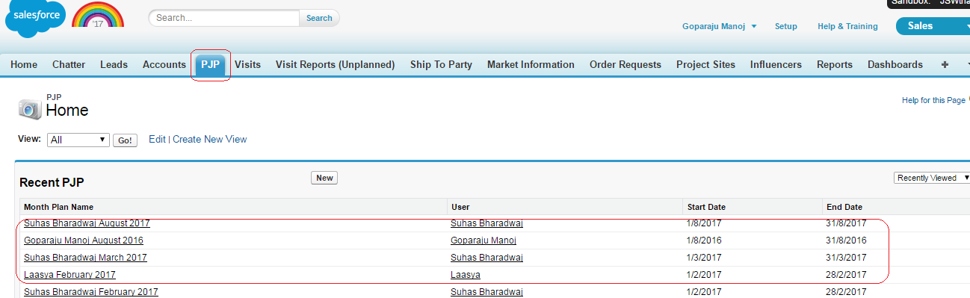

**2.2 Create New Month plan**

1) Click on “New” button from Month plan landing page

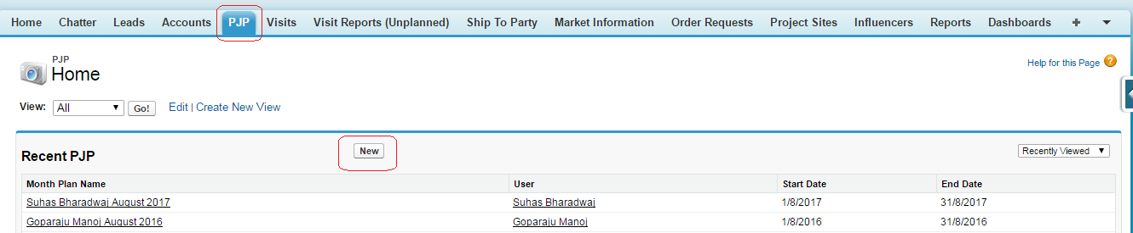

2) Select Record type “PJP” from pick list and click on Continue button

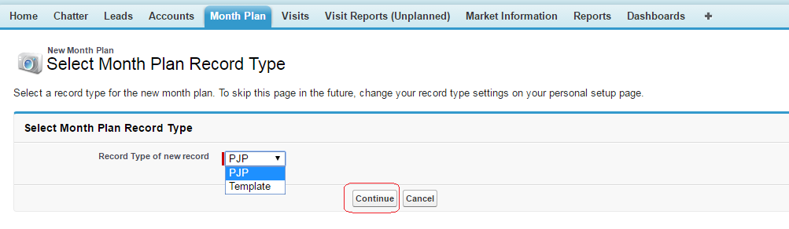

3) Select Month and Year

4) Click on “Create PJP” button

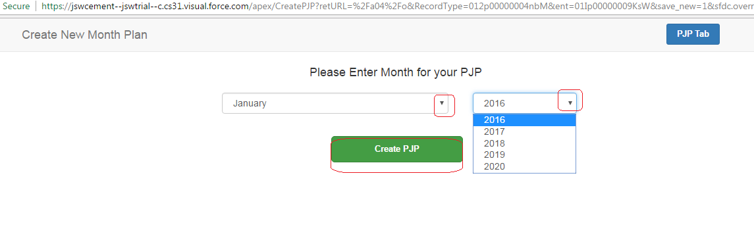

5) Navigates to New Personal Journey plan calendar

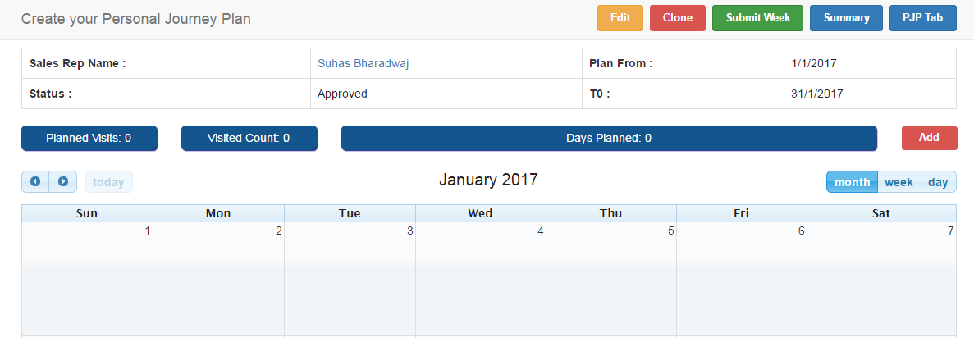

6) Sales Officer Name, Status as "New Request", Data which user need to plan on calendar will be displayed.

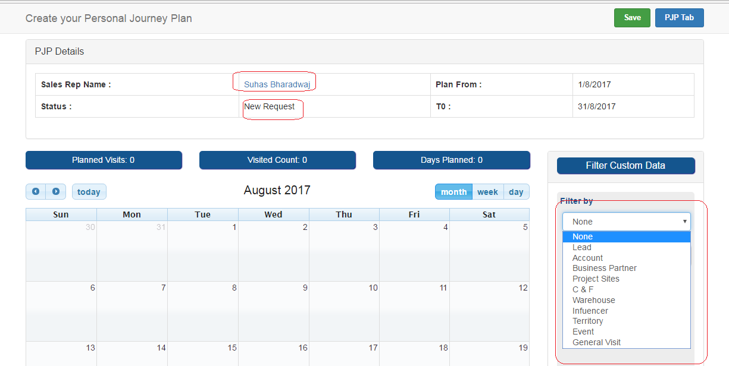

7) Select required data (Leads, Accounts, Business Partners,..ect) from list in order to incorporate in new journey plan

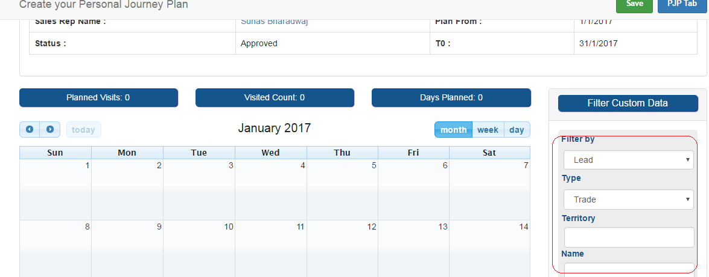

8) Click on Apply Filter, based on the filter process data (Leads, Accounts, Business Partners,..ect) will be displayed.

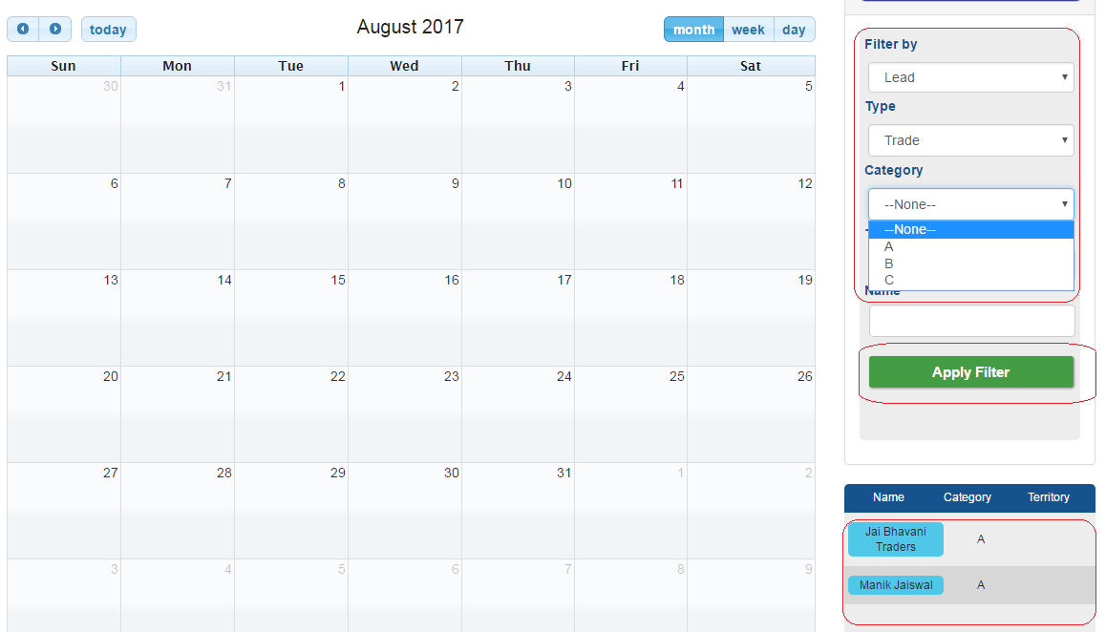

9) Drag and drop the data(Leads, Accounts, Business Partners,..ect) from right pane to calendar date

Drag the data(Leads, Accounts, Business Partners,..ect ) from right pane

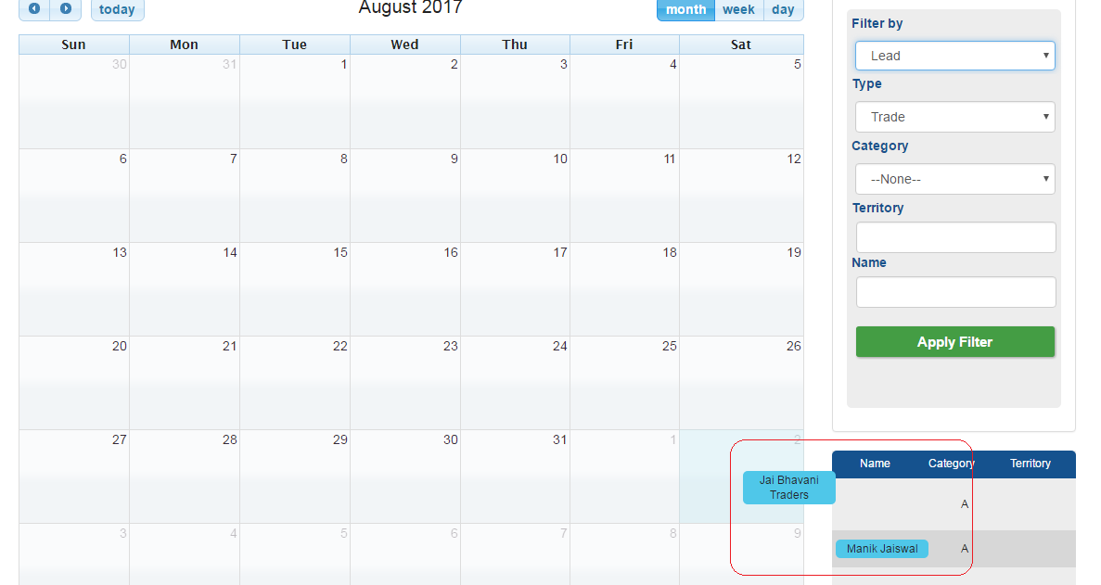

Drop the data under calendar date

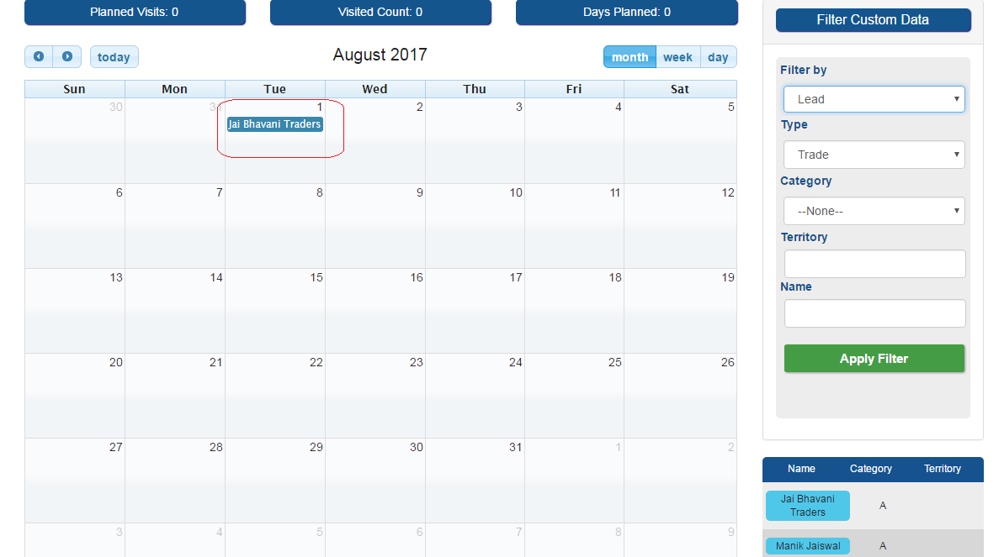

10) Click on Save after selected (Drag and Drop) data in to calendar and click on OK on pop up message.

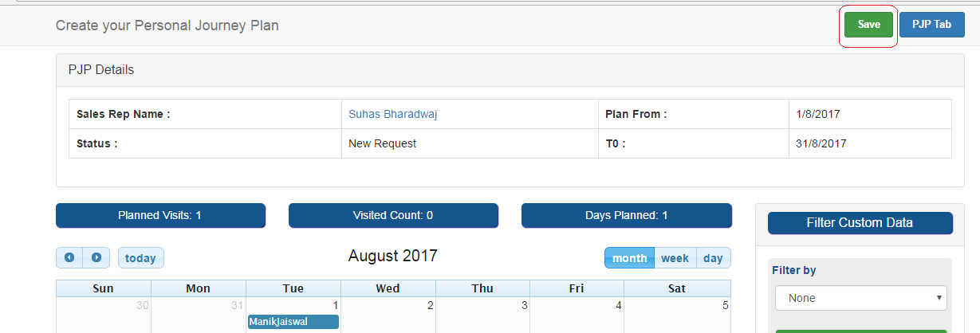

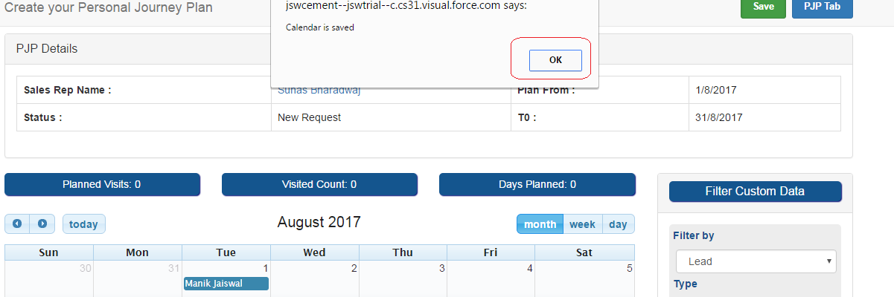

11) Month plan gets saved and navigate to Month plan detail page

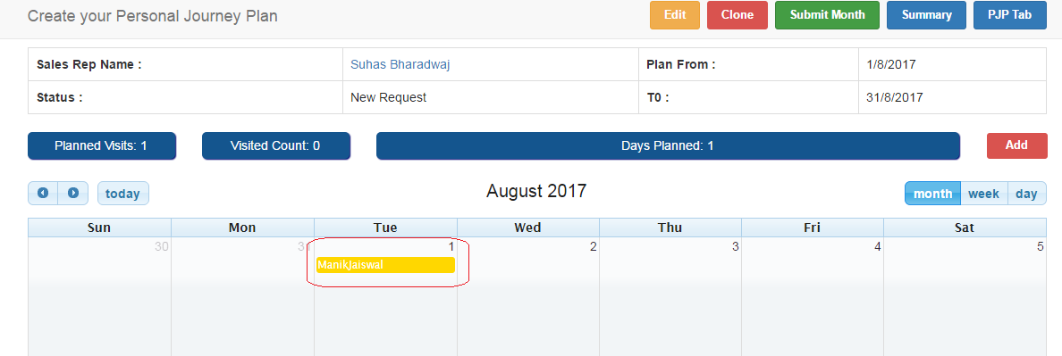

**2.3 Edit Month plan**

Month plan can be edited by adding data (Leads, Accounts, Business Partners,..ect) in to calendar and delete data from calendar when it is in New Request status.

1. Navigate to month plan landing page as mentioned above
2. Select Month plan from list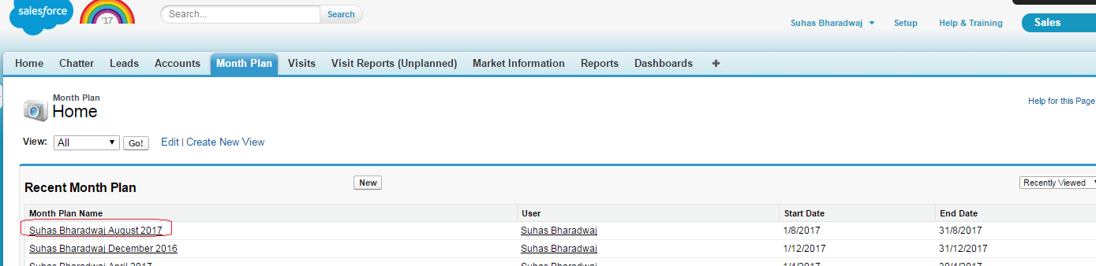
3. Click on Edit button

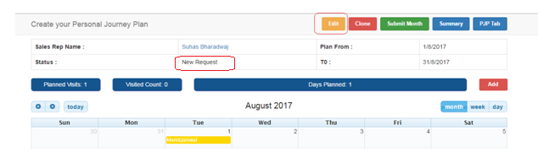

1. Add data (Leads, Accounts, Business Partners,..ect) in to calendar by using drag and drop as mentioned above

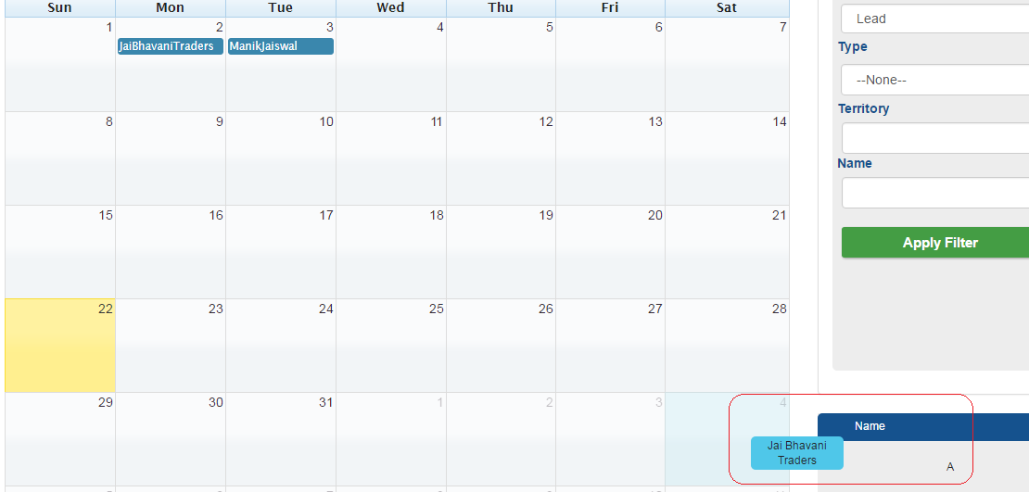

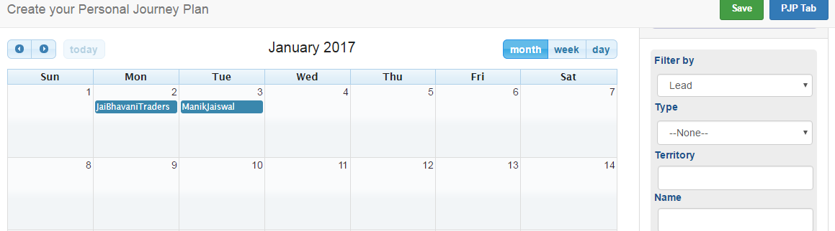

1. Delete data (Leads, Accounts, Business Partners,..ect) from calendar

Click on specific data (Leads, Accounts, Business Partners,..ect) under calendar date

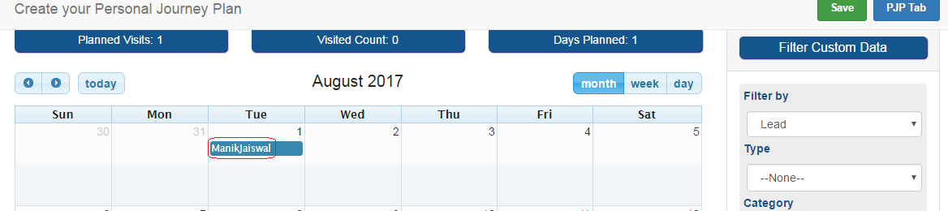

**2.4 Clone Month plan**

Instead of creating new month plan from scratch user can clone existing Month plan and edit data(Leads, Accounts, Business Partners,..ect) in to calendar

1. Navigate to month plan landing page as mentioned above
2. Select Month plan from list
3. Click on Clone button

Step :

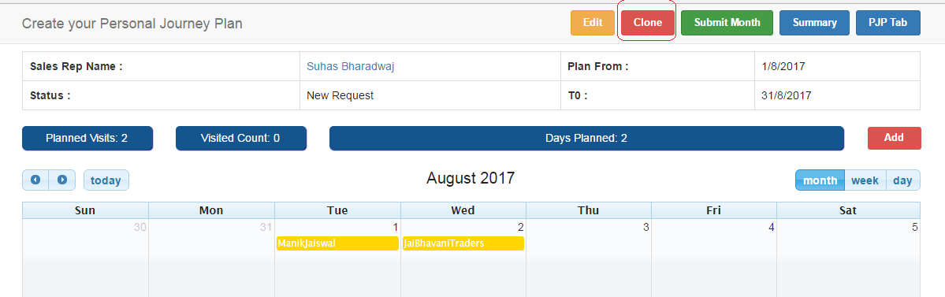

1. Edit (Change) Month and Year
2. Click on Create PJP

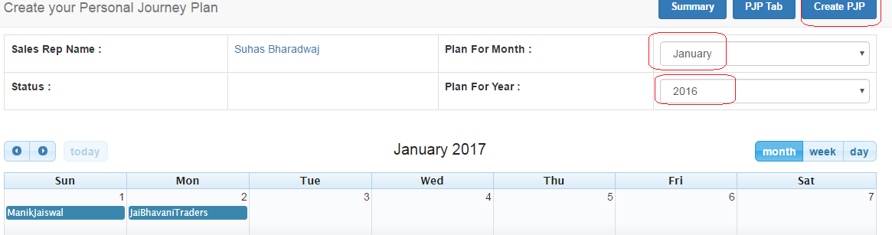

**2.4 Submit Month plan**

After Month plan created, it has to send for approval to hierarchy.

1. Create and save Month plan as mentioned above
2. Click on Submit Month plan.

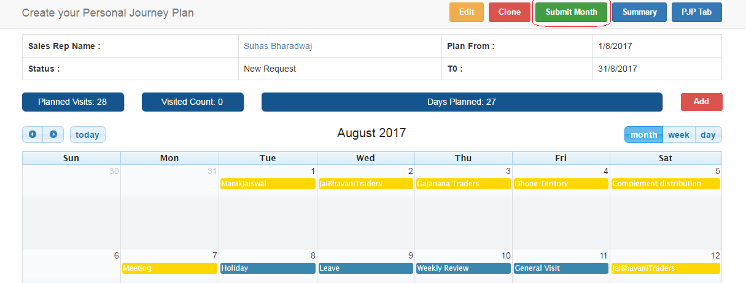

1. After submitting month plan for approval to hierarchy, Month plan status changes to Submitted.

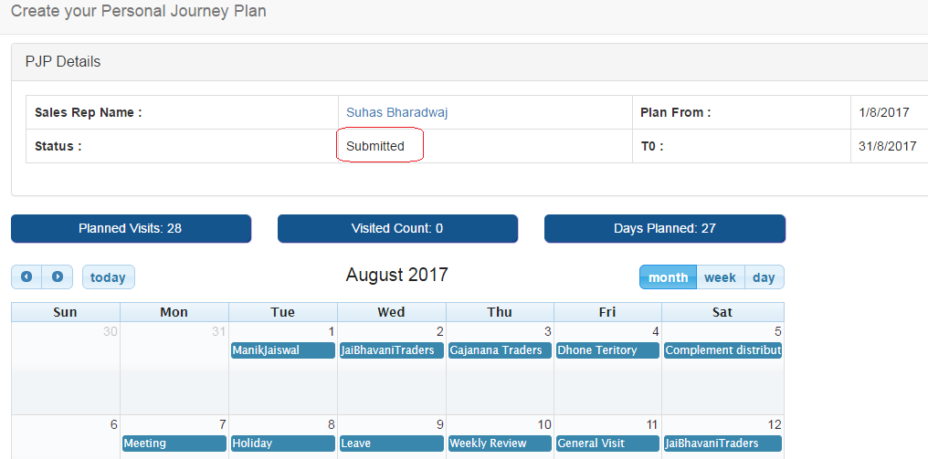

1. After submitting pjp for approval , hierarchy manager receive the link through email and can login to pjp which is sent for approval.
2. After submitting month plan for approval to hierarchy, SO will not have edit privileges on same month plan.

**3. Month Plan (PJP) Approval Process**

* 1. Login application with Hierarchy Manager credentials ( Please follow as mentioned above for SO)
  2. Hierarchy manager can login the month plan by clicking on link from email.
  3. Month plans which are sent for approval should appear to Hierarchy manager under Month plan Page.

1. Navigate to Month plan Tab

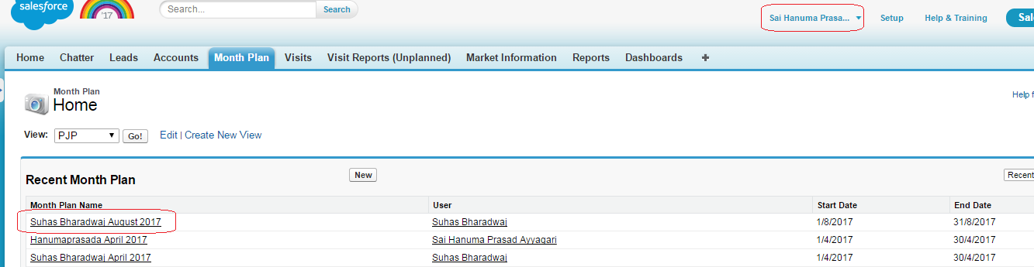

1. Select Month plan which need to Approve/Reject



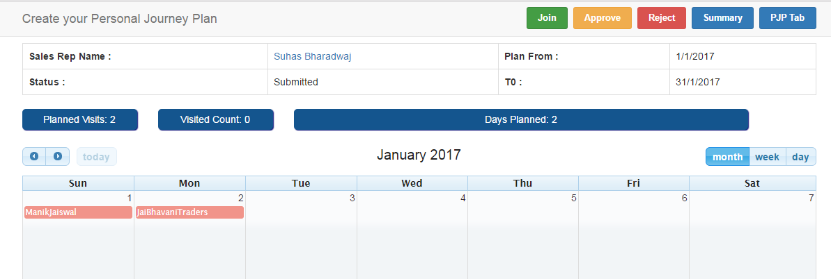

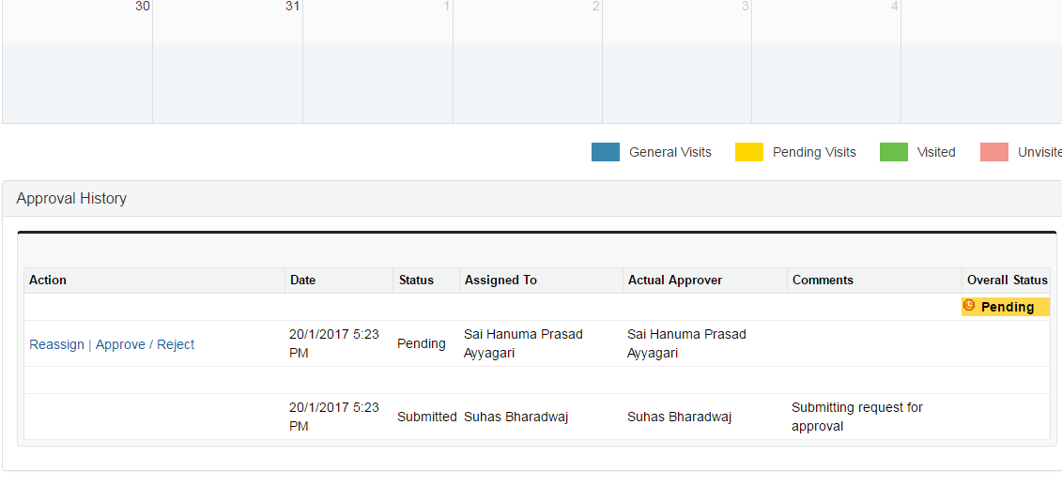

1. Click on Reject button to Reject Month plan.

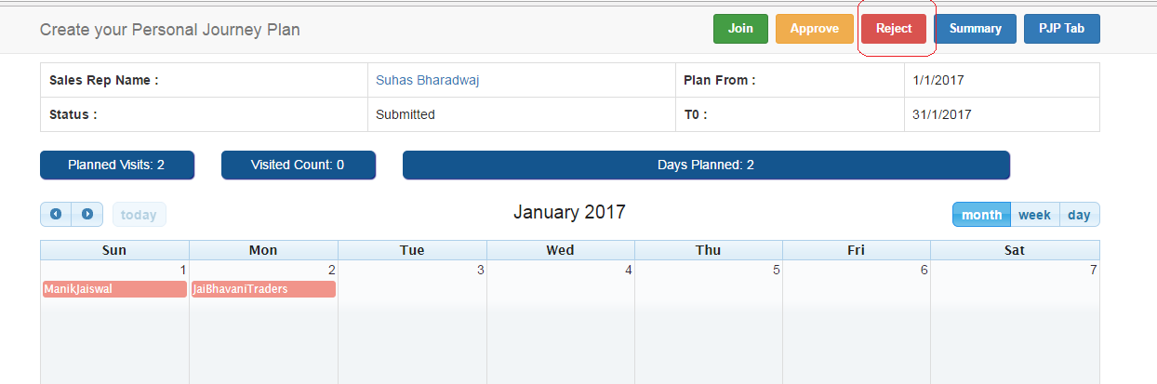

1. Navigates to Approve/Reject Approval Request page , need to enter comment under Comment text box and click on Reject button

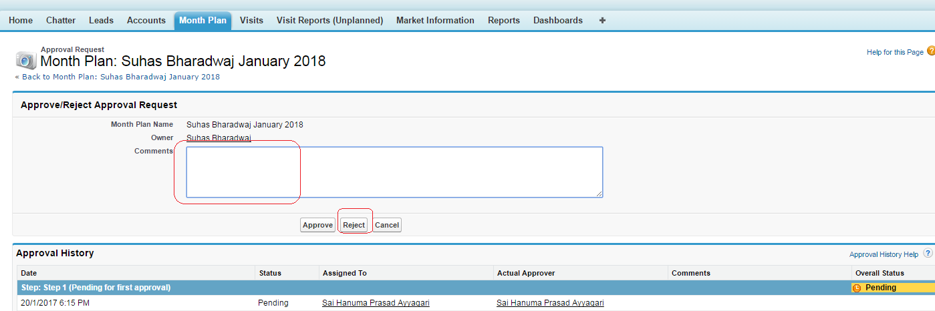

1. Navigates to Personal journey plan detail page and under Approval history section, status display as Rejected.

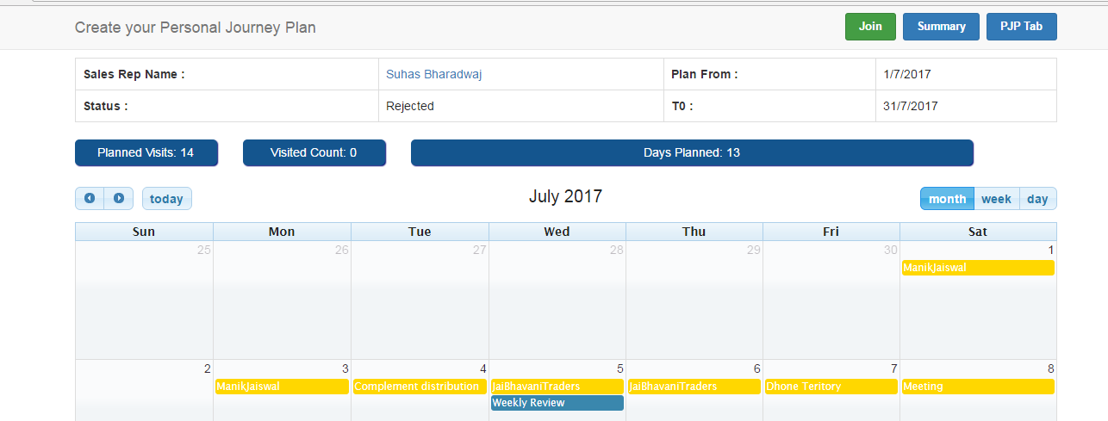

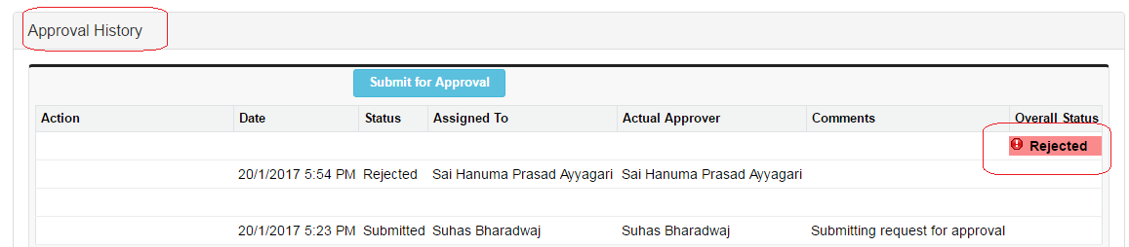

1. Login with Sales Officer credentials , edit the month plan accordingly and send it for Approval to hierarchy again (Please follow same process which is mentioned above)
2. Login with Hierarchy manager credentials and select Sales Officer’s month plan record which is sent for approval again (Please follow same process which is mentioned above) and Click on Approve button.

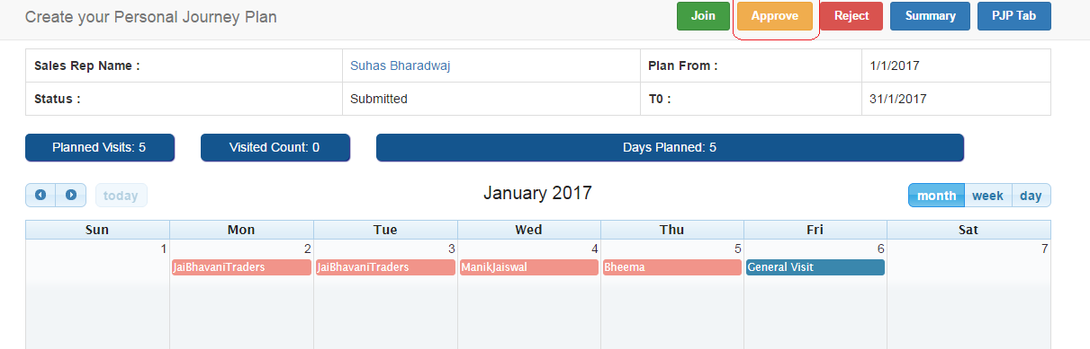

1. Navigates to Personal journey plan detail page , under Approval history section status display as Approved. Entire approval history will be displayed here.

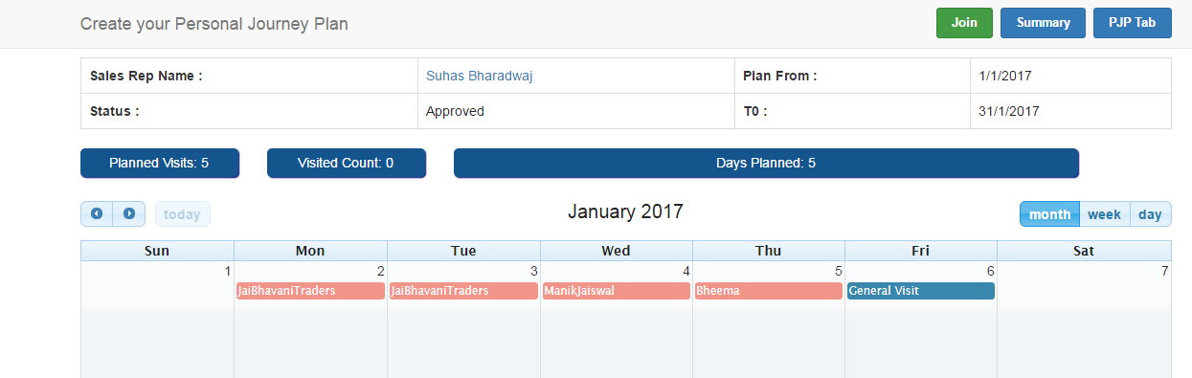

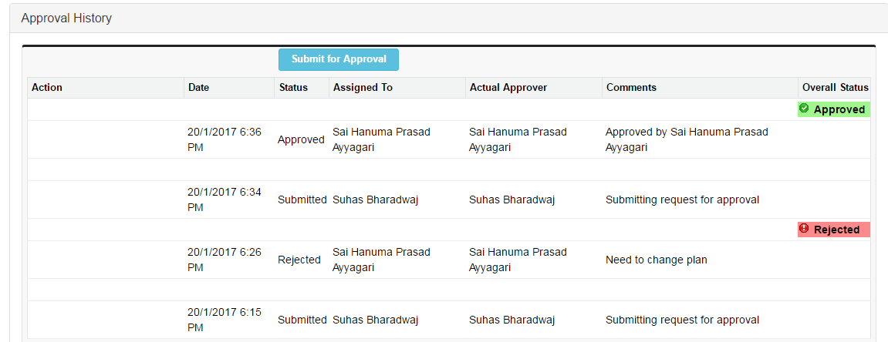

1. Login with Sales Officer credentials and navigate to Month plan record (Please follow same process which is mentioned above)
2. Click on Edit button and select week

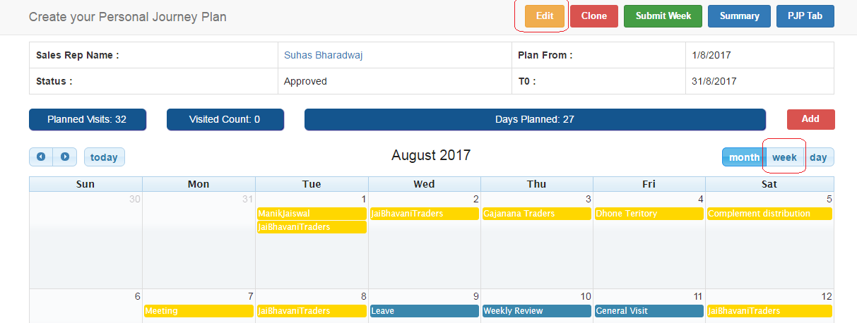

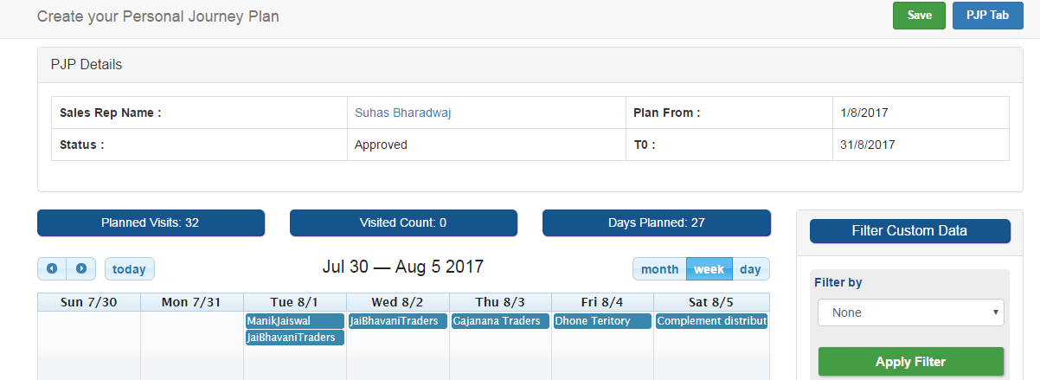

1. Select Required week to edit by using side arrow buttons.

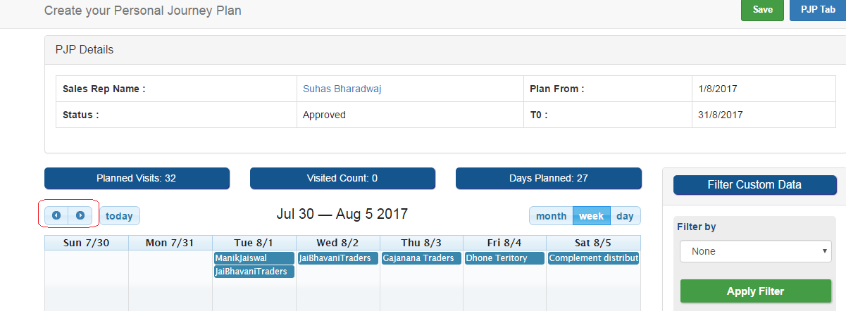

1. Edit weekly plan and click on save button to edit weekly plan. Add data by using drag and drop (or) delete data (Please follow same process which is mentioned above for Month plan edit)

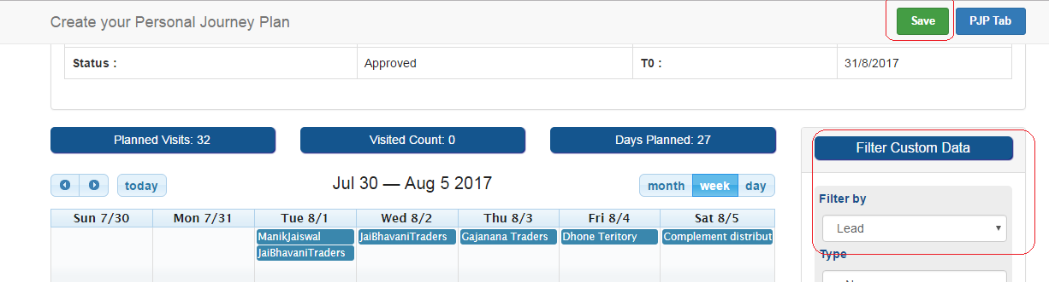

1. Click on Submit week button

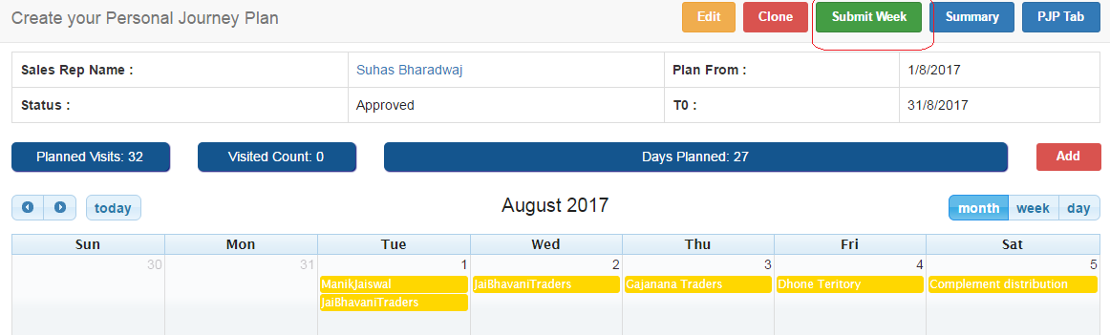

1. Select week and click on Submit for approval button.

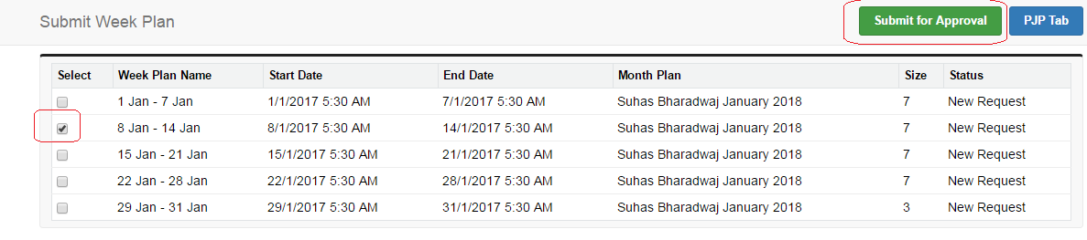

1. Login with Hierarchy manager credentials and navigate to Sales Officer’s Month plan record (Please follow same process which is mentioned above)

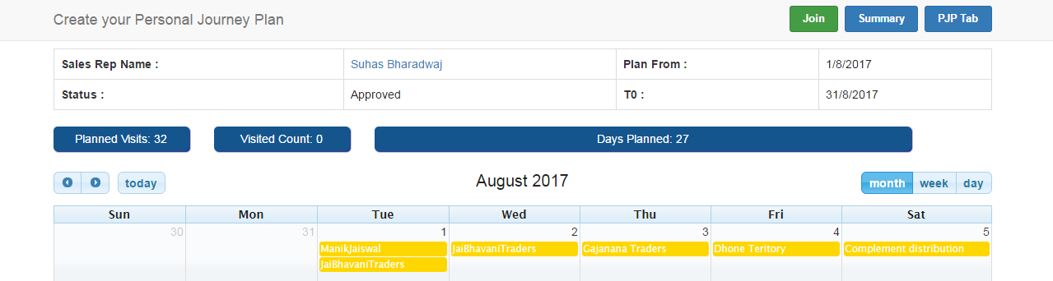

1. Click on week plan option at bottom and select on Week plan which is in submitted status

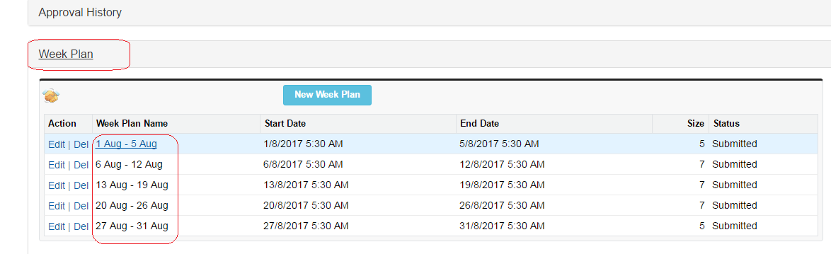

1. Click on Approve/ Reject button (Please follow same process which is mentioned above for Month plan Approval process)

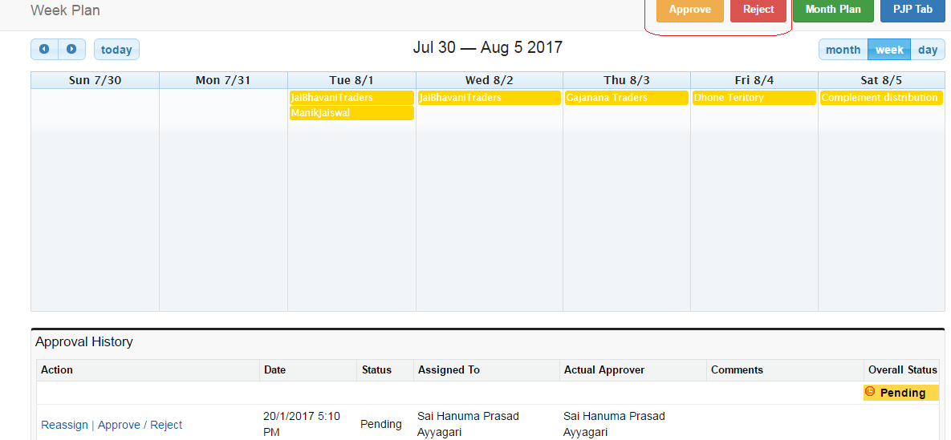

**4. Visit Record**

During creating Month plan , when user drag and drop the data and save the month plan visit record gets generate automatically.

Even Visit record can also create manually for unplanned visits. After creating visit record manually that data reflects on journey plan calendar automatically.

4.1 Navigate Visit record from Calendar

1. Navigate to month plan landing page as mentioned above
2. Select month plan from list

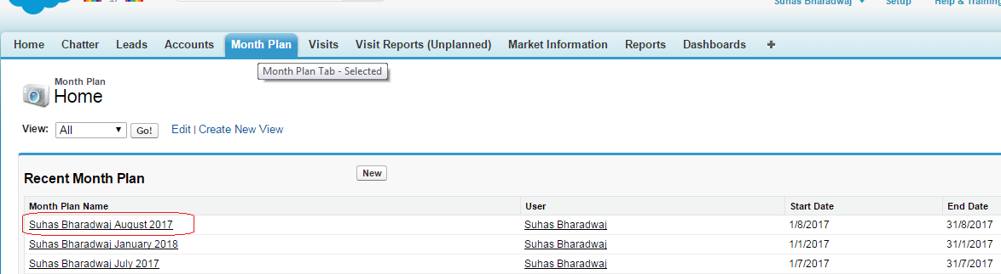

3) Click on data from Calendar date block

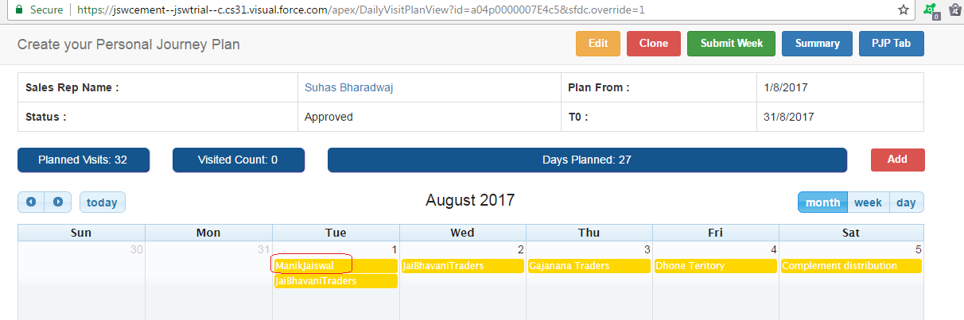

4) Navigates to visit record which is relevant to selected data on calendar

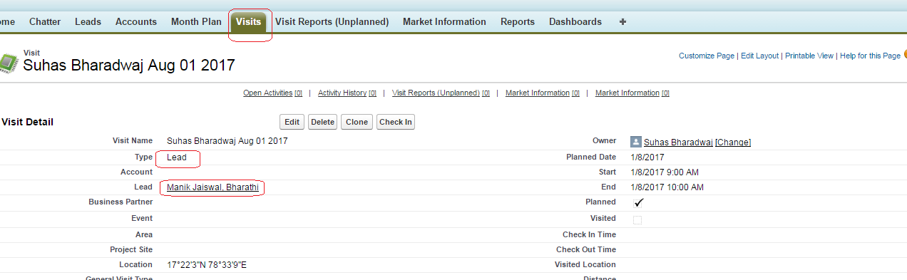

4.2 Navigate Visit record from Visit tab

1. Login to SFDC Application
2. Click on Visits Tab

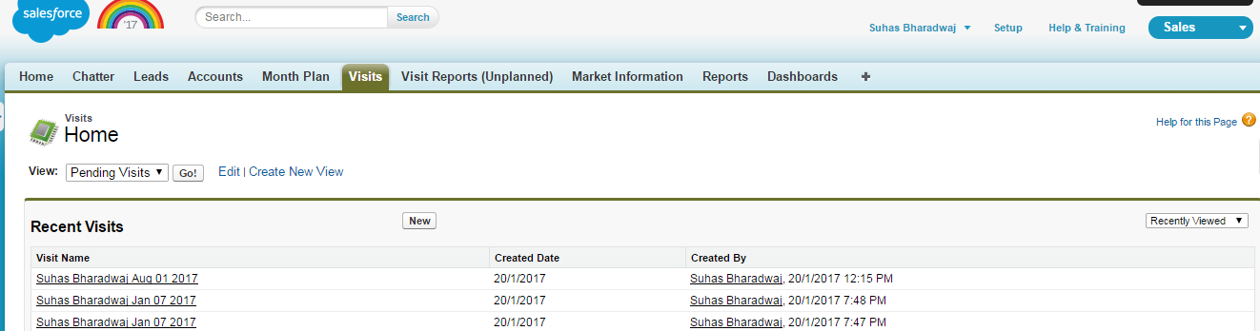

3) Click on Visit record which is available from list.

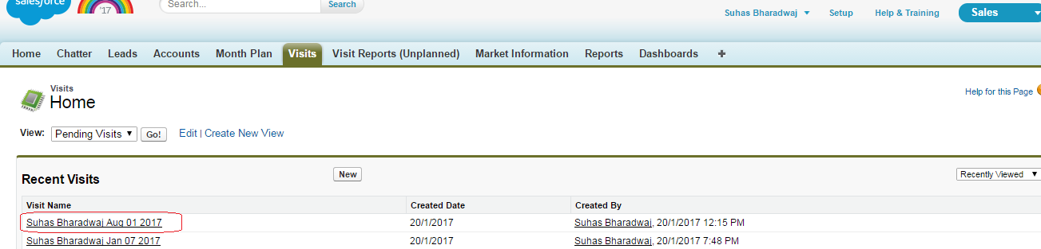

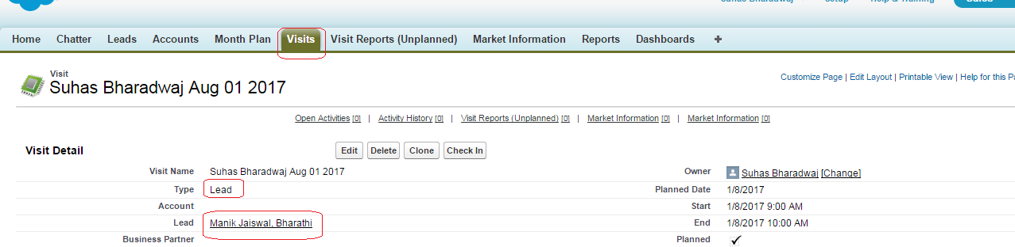

**4.3 Create Visit record manually for unplanned visit.**

1. Login to SFDC Application
2. Navigate to Month plan page

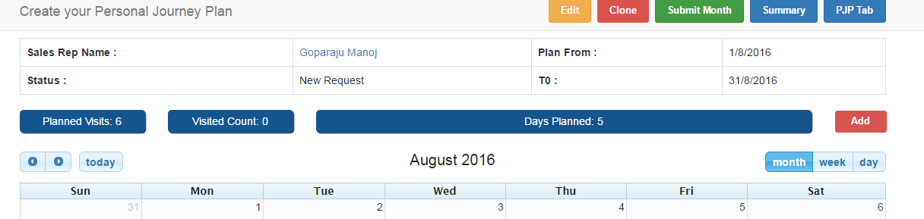

3) Click on Add Button.

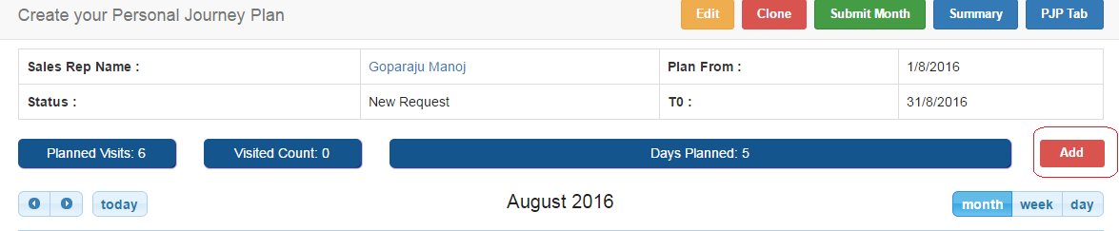

4) Navigates to new visit page.

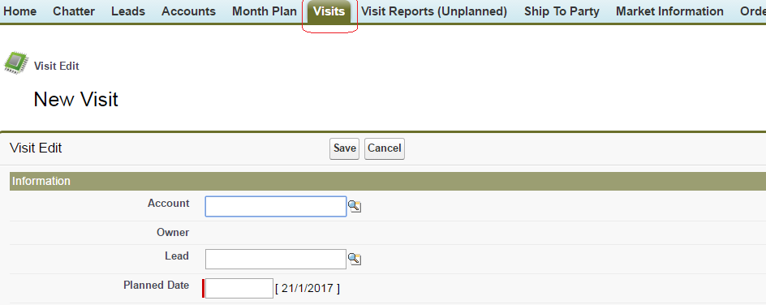

5) Select Lead/Account/Business Partner/Event/Territory/Project site

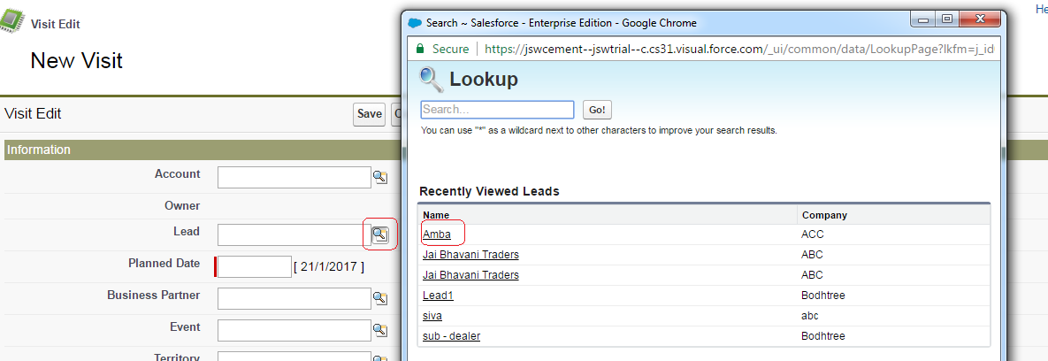

6) Select Planned date, Start, End dates and click on Save button.

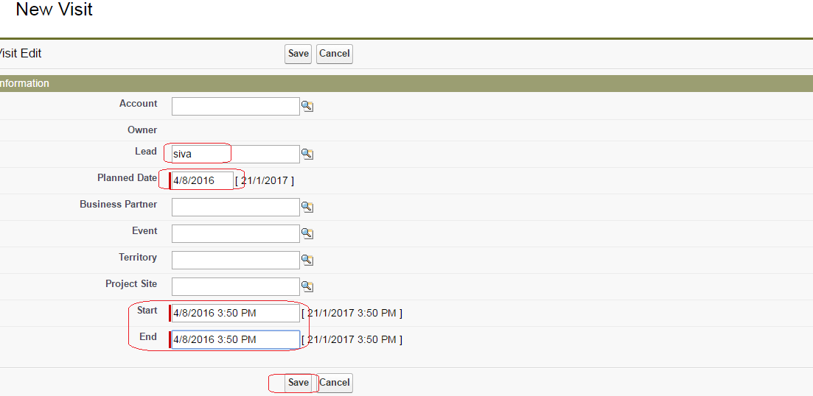

7) Unplanned visit get save and re navigate to Month plan page , data (Lead (or) Account....) will display on calendar page.

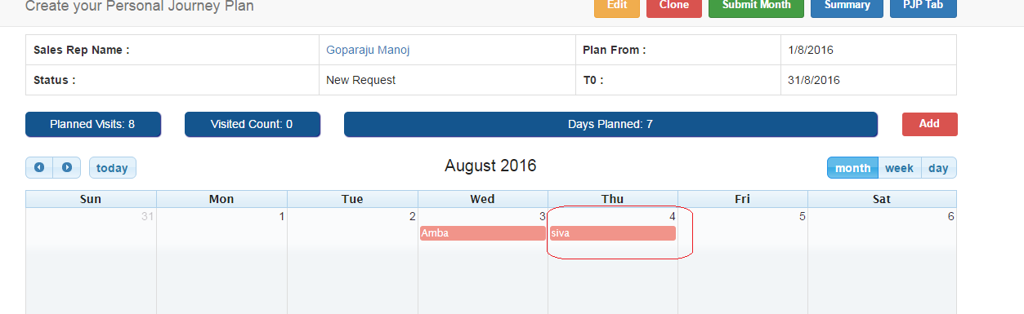

4.4 Visit Address through Google map

1) Navigate Visit record from calendar

click on record under calendar block.

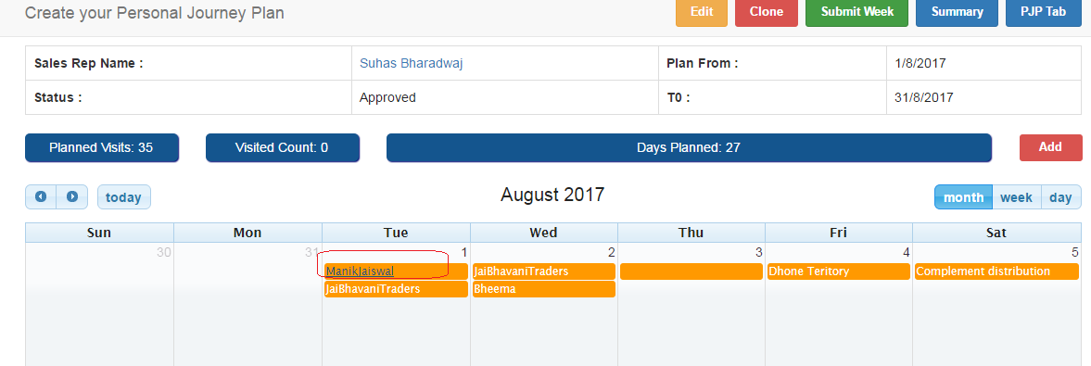

2) Navigate Visit record from calendar and observe google map of selected Lead/Account/Business partner....address under Visit address section.

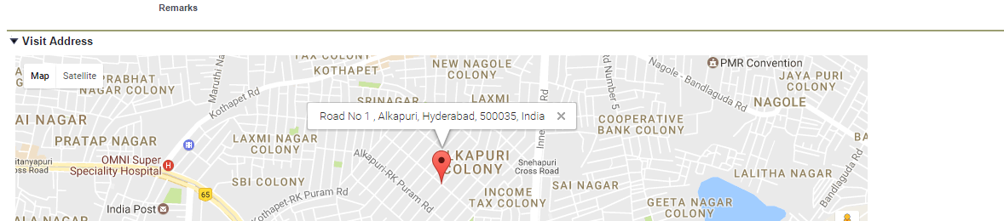

4.5 Check in and Check out of Visit

1) Navigate Visit record from calendar

click on record under calendar block.



2) Click on Check in button

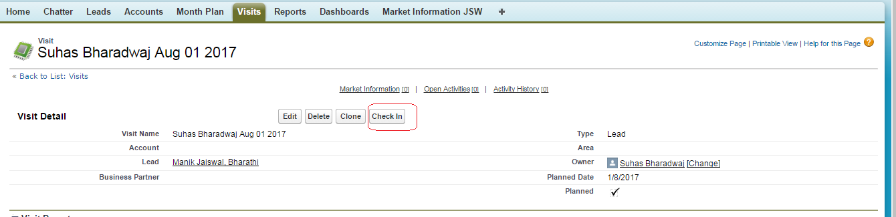

3) Click on Check out button.

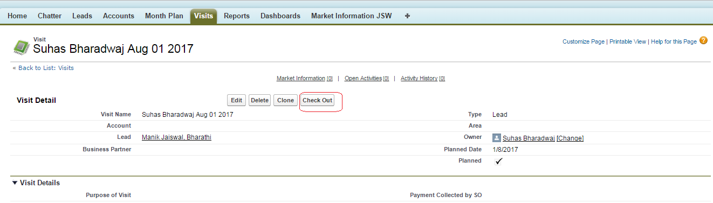

4) navigates back to visit record detail page.

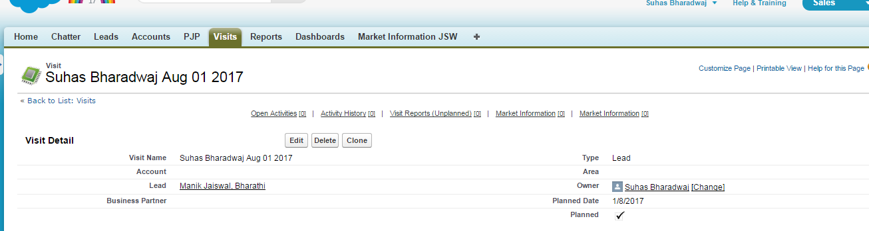

5) Navigate to Month plan calendar and observe the record which is visited.

If check in , check out address matches with record address (Leade (or) Account (or) Business partner which is under calendar ) it turns in to green.

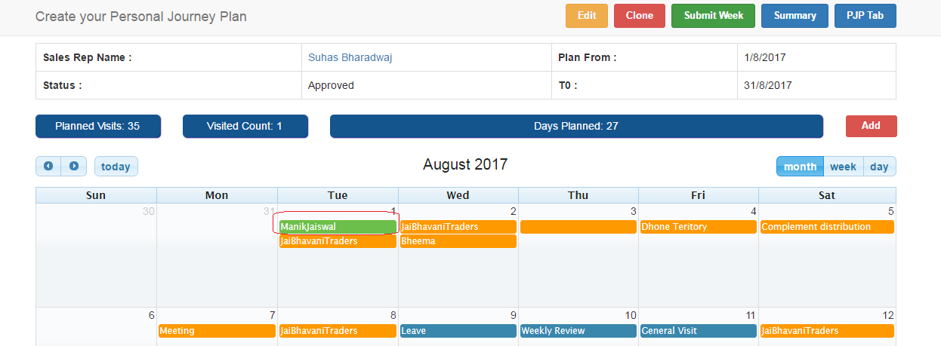

4.6 Longitude and Latitude address mapping

1) Navigate to Month plan calendar and observe the records which are visited.

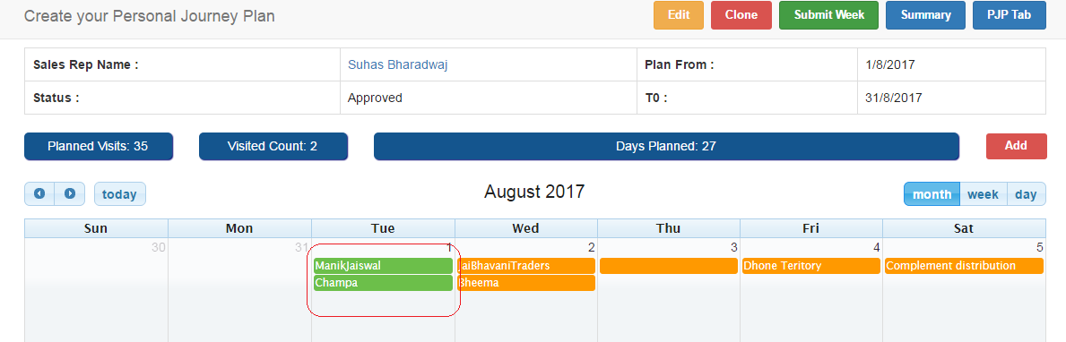

2) Click on Day block and observe Longitude and Latitude map .

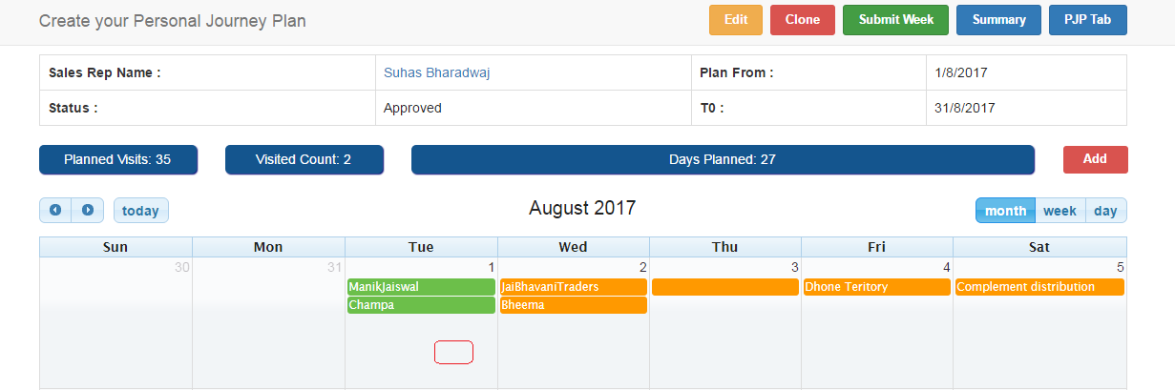

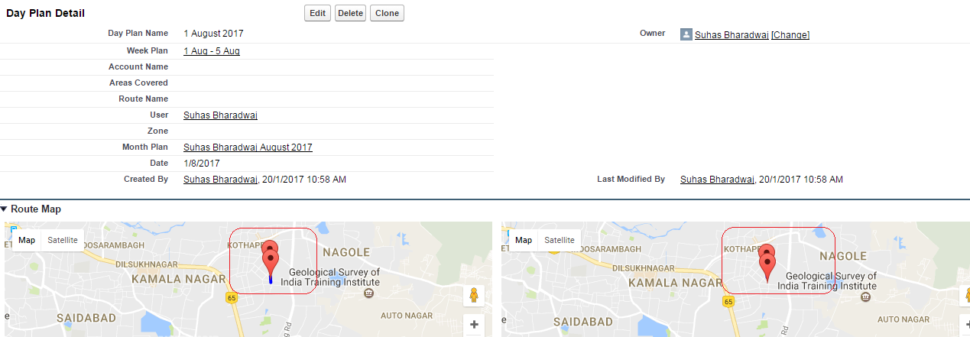

3) Different Visit types under Month plan calendar (Visited/Not visited/General visit) display in different colors.

Visited --- In Green

Not Visited --- Orange

General Visits ---- Blue

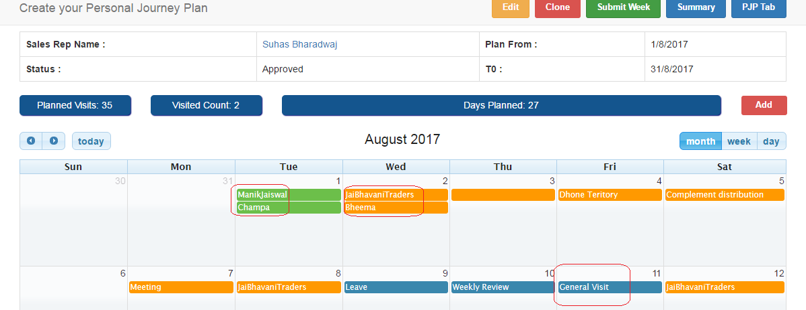

4) Planned Visits , Visited count, days planned will display/update accordingly.

